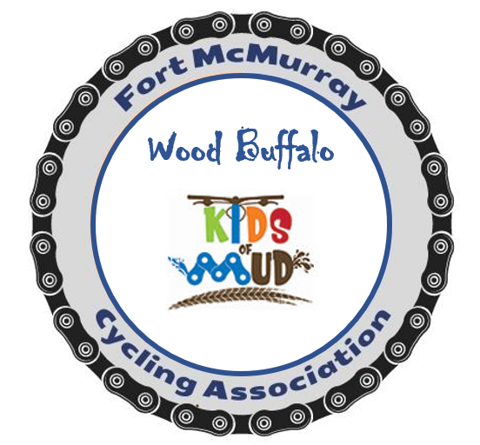FMCA Kids of Mud Registration Guide

Go to Home (albertabicycle.ab.ca) and click on Purchase a Membership at the top.
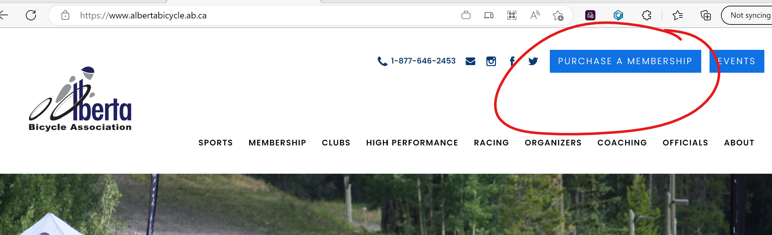

Step 1: 2023 AB Bicycle Membership page will open, read through and click the continue button at the very bottom of the page.
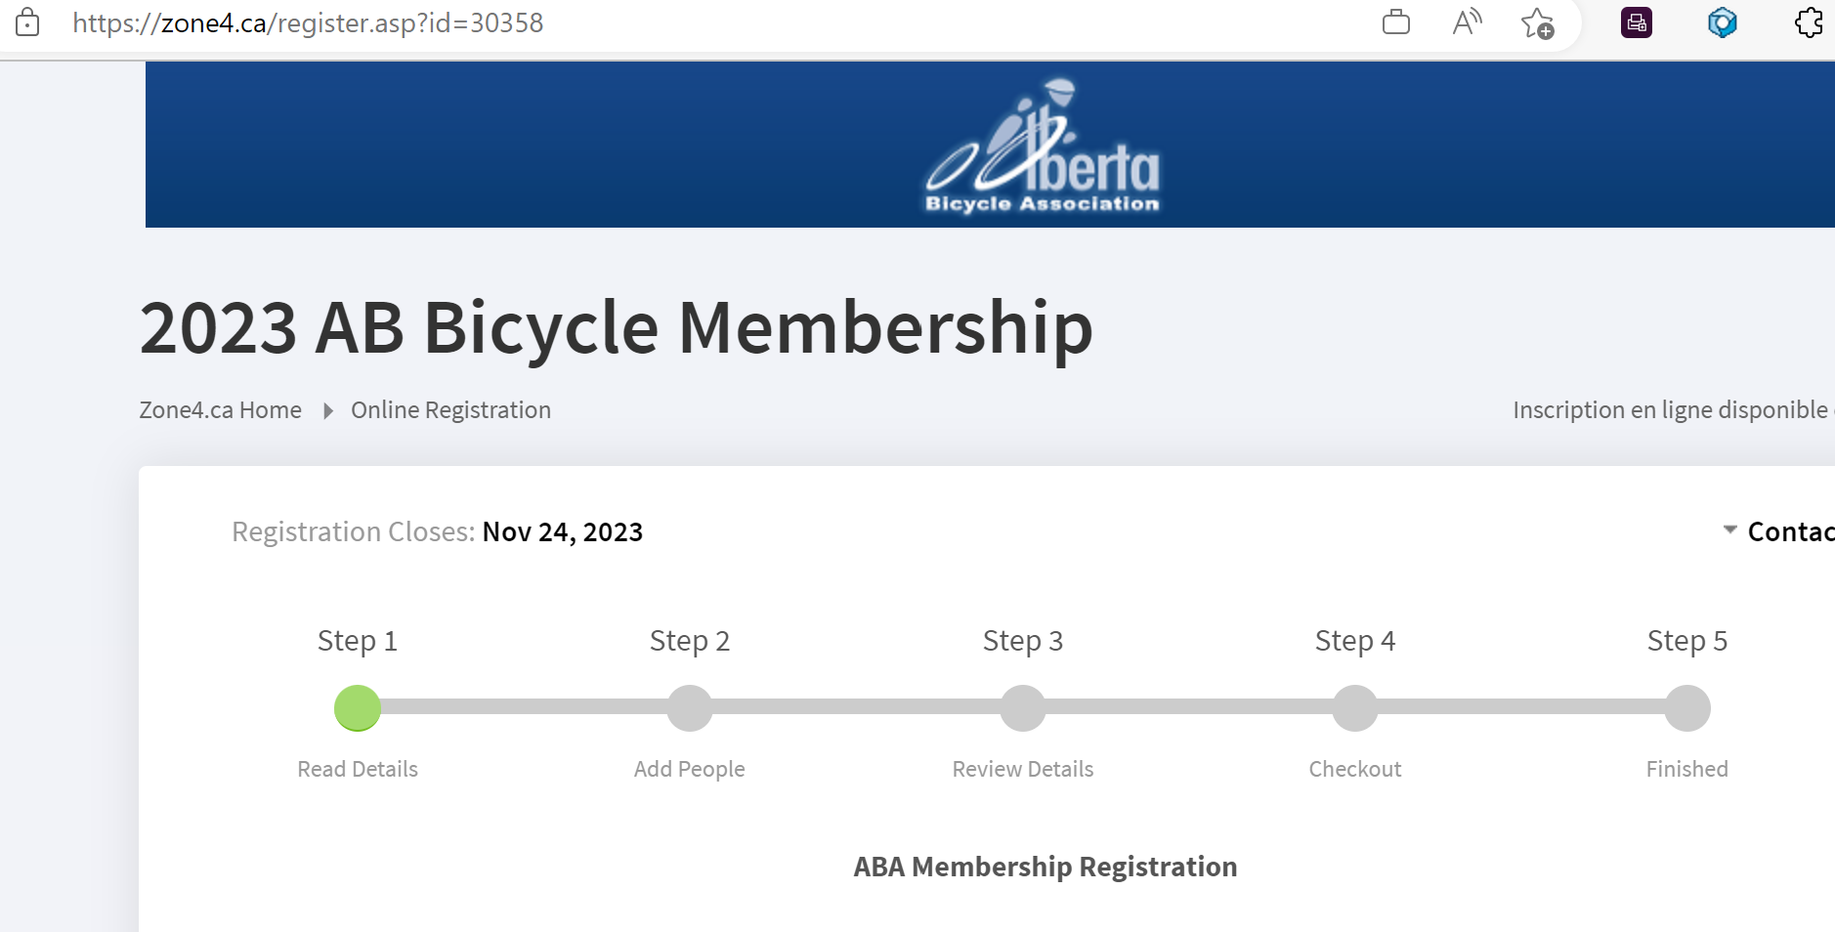

Step 2: Add a person or click the button “add a person” if you are already a member. (black button)
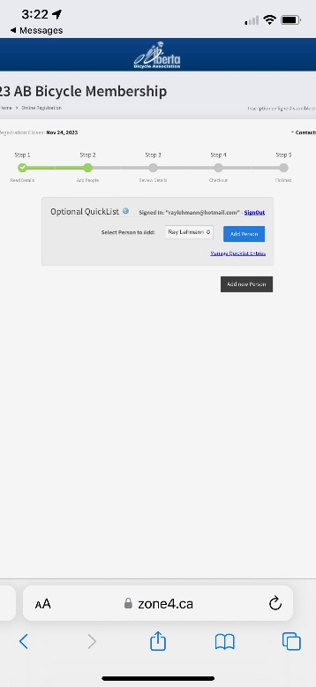

Step 3 Choose club status $0, then select Fort McMurray Cycling Association.
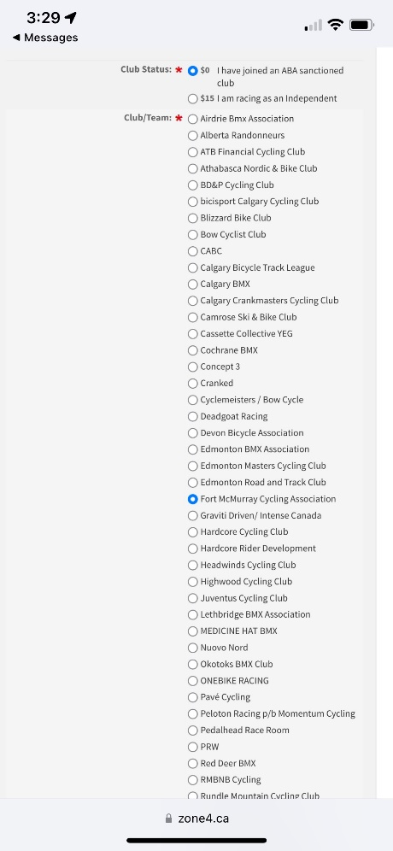
Step 4: Then also select kids of Mud.
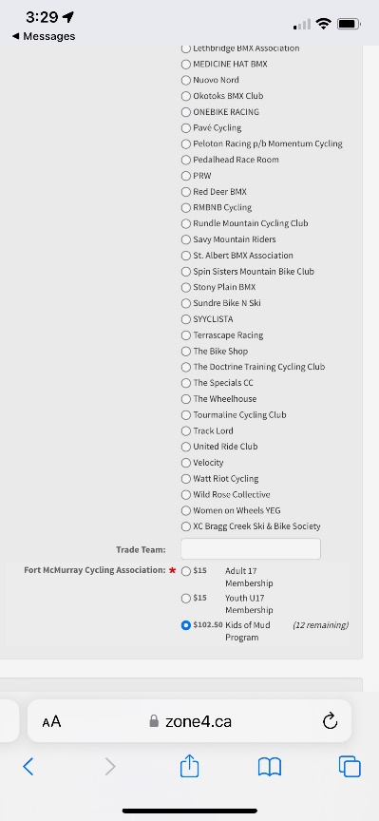
Step 5: Select U17 non racing membership and XC as primary dicipline and fill out the minor/guardian information.
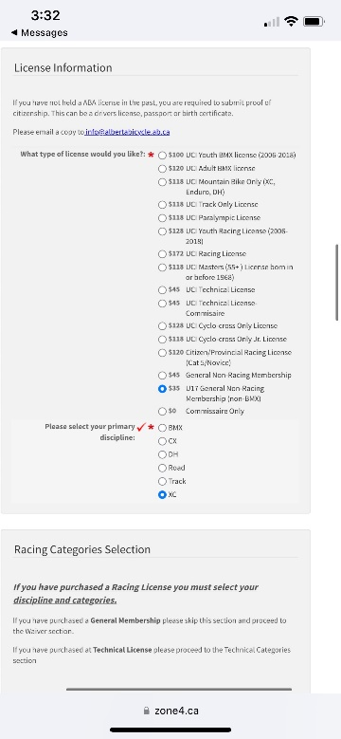
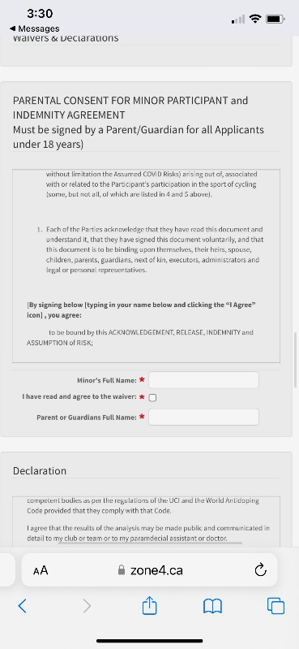
Step 6: Select consent for both, plastic copy not required by club, optional insurance not required.
